Fantasy F1

Scoring/Betting Systems
Top 10 Drivers per race
Drag and drop with all 20 listed
Exact pos, (F1 points) 25, 18, 15, 12, 10, 8, 6, 4, 2, 1 Driver in top 10 but wrong position 2
Top 5 Constructors
Also driver points system 25, 18, 15, 12, 10 (10 for wrong pos in top 5) Drag and drop with all 11 listed
Bonus Predictions
Fastest Pitstop (Constructor): 10 points
Drop down menu
Pole position: 10 points
Drop down menu Fastest lap: 10 points
Drop down menu

Sprint:
First retirement (or no retirement): 10 points Drop down menu
Safety car/VSC deployed: 5 points yes/no (slider like)
Red flag: 1 point correct no, 5 points correct yes yes/no (slider like)

Exact pos, (F1 points) 8,7,6,5,4,3,2,1 points Drag and drop
Same bonus predictions from race also for sprint
Season-Long Predictions:
Ranking all 22 Drivers: x10 from races
250, 180, 150,... outside top 10 but correct position: 10 points Driver in top 10 but wrong position 20 points
Drag and drop
Ranking all 11 Constructors: x10 from races
250, 180, 150,... outside top 5 but correct position: 10 points Constructor in top 5 but wrong position 20 points
Drag and drop
Most pole positions: 100 points Drop down menu
Most fastest laps: 100 points Drop down menu
Fastest Pitstop (Constructor): 100 points
Drop down menu

Stats Visualization
Profile Stats
- Total points (trend indicator)
- Avg points per race
- Best/worst race + amount of points
- Prediction accuracy rate by category
- Correct top 10 picks: X/Y (percentage)
- Bonus prediction success rate
- Current streak (races with 50+ points scored)
- Favorite driver/constructor performance
- Donut Chart, percentage of points per category Global Stats
Interactive Line Chart
  - X-axis: Race rounds (name of grand prix)
  - Y-axis: points
  - Multiple lines: two per user (color-coded?), one for total cumulative points, one for points per race weekend
  - Hover tooltips: profile name, total points and points for that race
  - Toggle users on/off for every user
  - (Zoom/pan) Other optional visualization ideas
Heatmap: Prediction accuracy across races/users Leaderboard table with sortable columns:
rank change indicator (arrows up/down) points behind leader
recent form (last 3 races) Race-specific Stats
Head-to-head comparison tool between users? (similiar layout to f1 broadcast comparison between two drivers? idk )
Prediction consensus (which driver did most users pick for pole, p1, constructor,...?)
Biggest upset (most unexpected result affecting predictions, idk wie man das miest though? Maybe later as feature)

Sec-layout
- Supabase Auth for login/account management
- No pw requirements (Itsec, allow all chars)
- Email verification? (pw reset)
- JWT tokens, session management (Supabase handling?)
- Rate limiting for login attempts (maybe Vercel Edge Config)
- Environment variables in Vercel for secrets
- Activate Row-level sec in Supabase
- "Remember me" functionality
- Session timeout after ~30 days
- Optional: Google OAuth?
- input validation and prepared statements for DB operations
- Pretty much no user unique user input other then name and password, everything else prepared drag and drop or drop down, etc.

Database Layout
-- User Profiles CREATE TABLE users(
id UUID REFERENCES auth.users PRIMARY KEY,
username VARCHAR(30) UNIQUE NOT NULL,
display_name VARCHAR(50), favorite_team_id VARCHAR(50), favorite_driver_id VARCHAR(50), created_at TIMESTAMP DEFAULT NOW()
);

-- Races
CREATE TABLE races (
id SERIAL PRIMARY KEY, season INTEGER NOT NULL, round INTEGER NOT NULL, name VARCHAR(100),
circuit VARCHAR(100), country VARCHAR(50), date TIMESTAMP,
cutoff TIMESTAMP, --used to trigger evaluation after race has_sprint BOOLEAN DEFAULT FALSE,
status VARCHAR(20) DEFAULT 'upcoming', -- upcoming, locked, completed UNIQUE(season, round)
);

-- Predictions
CREATE TABLE predictions ( id SERIAL PRIMARY KEY,
user_id UUID REFERENCES profiles(id), race_id INTEGER REFERENCES races(id), p1_driver VARCHAR(50),
p2_driver VARCHAR(50),
-- ... p3 through p10 pole_position VARCHAR(50), fastest_lap VARCHAR(50), safety_car BOOLEAN, red_flag BOOLEAN,
-- ... other bonus predictions points INTEGER DEFAULT 0,
submitted_at TIMESTAMP DEFAULT NOW(), UNIQUE(user_id, race_id)
);

-- Race Results
CREATE TABLE results (
id SERIAL PRIMARY KEY,
race_id INTEGER REFERENCES races(id), p1_driver VARCHAR(50),
p2_driver VARCHAR(50),
-- ... p3 through p10 pole_position VARCHAR(50),
fastest_lap VARCHAR(50), safety_car BOOLEAN, red_flag BOOLEAN,
-- ... other bonus predictions information created_at TIMESTAMP DEFAULT NOW()
);

-- scoring (store computed points per prediction) CREATE TABLE points_log (
id serial PRIMARY KEY,
user_id uuid REFERENCES users(id), race_id int REFERENCES races(id), session_type text,
total_points int, driver_positions int, fastest_lap int, constructor_predictions int,
… -- breakdown e.g., {"driver positions":43,"fastest_lap":8,...} created_at timestamptz DEFAULT now()
);

-- Leaderboard (materialized view for performance) CREATE MATERIALIZED VIEW leaderboard AS SELECT
user_id, username,
SUM(points) as total_points, COUNT(*) as races_predicted,
RANK() OVER (ORDER BY SUM(points) DESC) as rank FROM
predictions p JOIN
profiles pr ON p.user_id = pr.id GROUP BY
user_id, username;

Tech Stack
React/Next.js, Python (Flask/FastAPI) as Vercel functions to replace traditional backend, PostgresSQL + ORM: SQLAlchemy + Alembic, D3, Tailwind css

API Endpoints F1 APIs
- OpenF1 API (New, Official-ish) URL: https://openf1.org/
Real-time data during race weekends Live timing, positions, car telemetry Free and open source

- Jolpica F1 API (Ergast Alternative)

URL: https://api.jolpi.ca/ergast/f1/ Drop-in replacement for Ergast Actively maintained

Performance
  - Precompute aggregates after each race in a leaderboards table (background job)
  - Don’t compute heavy queries on every page view.
  - render charts client-side for interactivity, server-side aggregate data, send small payloads (e.g. series arrays)
  - Use css to change highlight color on profile based on fav. team/driver

Layouts

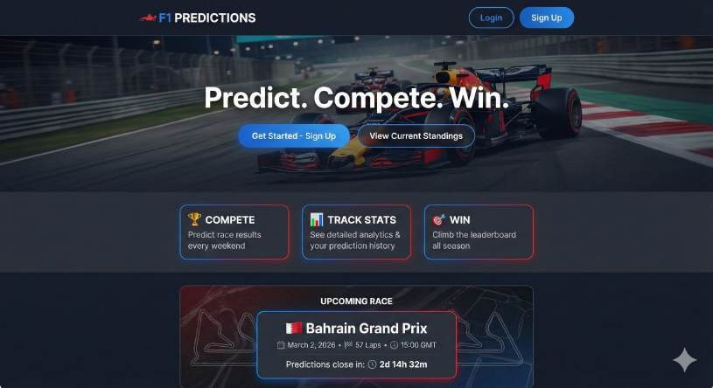
/landing

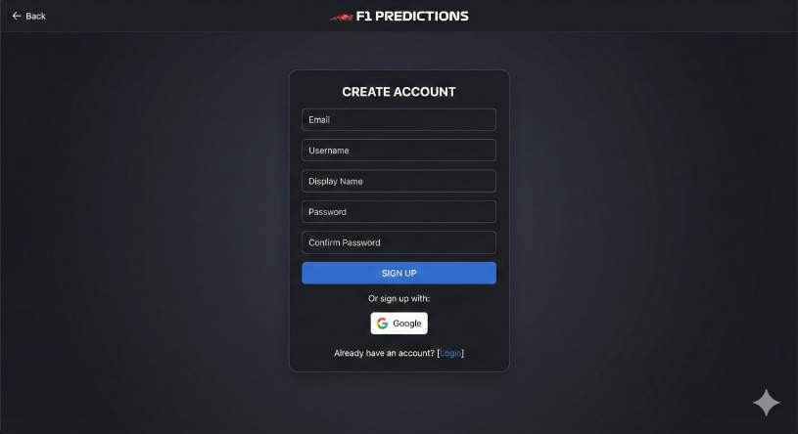
/sign-up

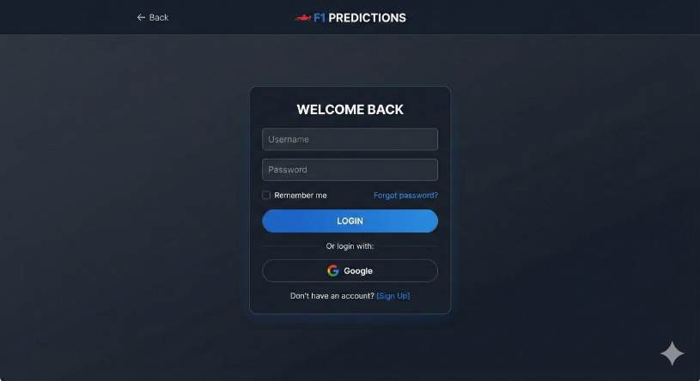
/login

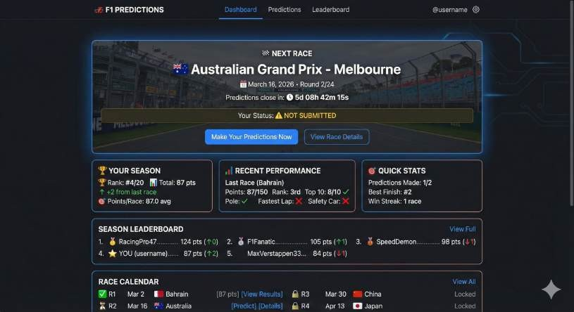
/home
/race-predictions
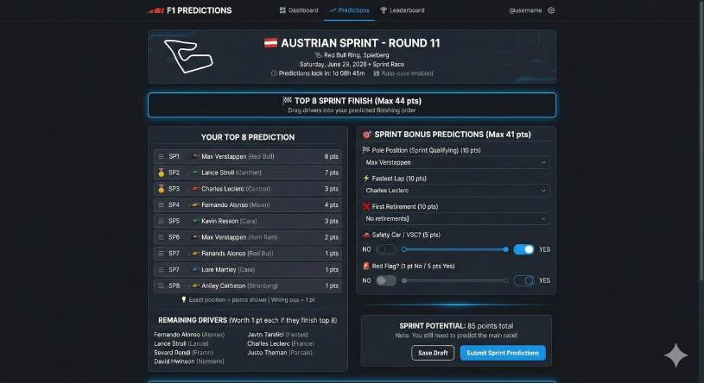
just adjust values from sprint to race predictions but layout remains similiar enough to this

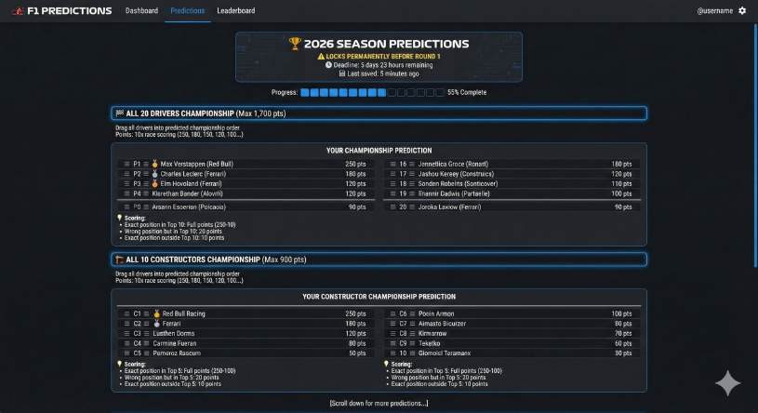
/season-predictions

/sprint predictions

/leaderbord

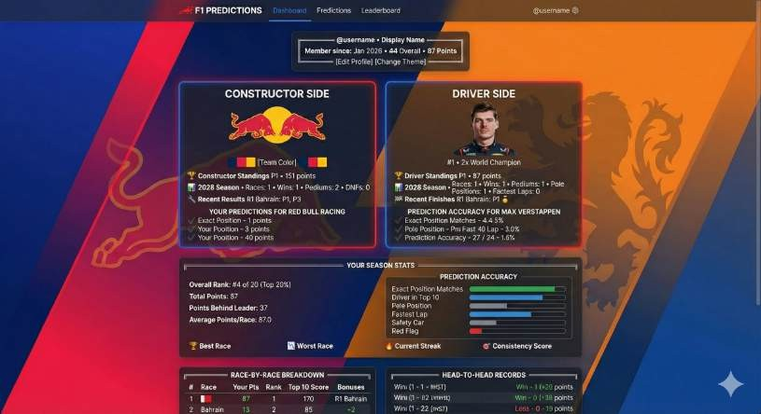
/profile

/race-results

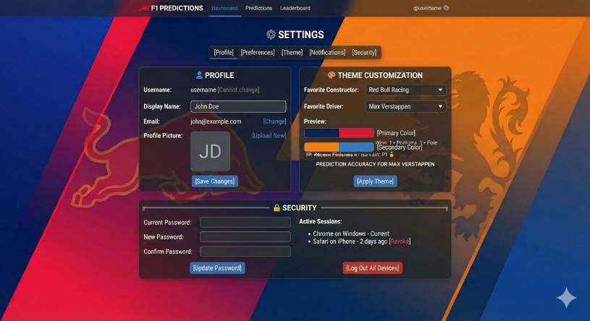
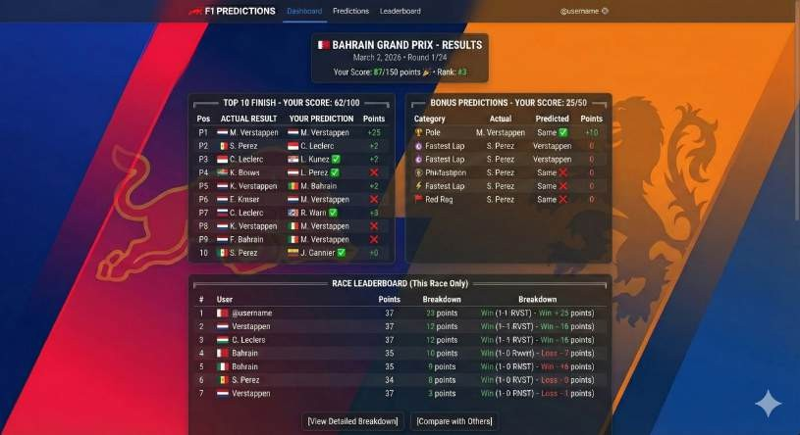
/profile-settings
/admin

